The following information has been collected from OSHA / Cal/OSHA, the World Health Organization (WHO), the Centers for Disease Control (CDC), and other sources designed to assist in providing guidance in developing a response plan for safety during the pandemic. THIS IS NOT A PROGRAM! Check with the CDC and other local regulatory agencies frequently for requirements and updates as things change frequently. References and resources are provided at the end of this document with blue underlined text serving as links.

Introduction:
Coronavirus (COVID-19) is a severe acute respiratory syndrome coronavirus. There are two routes of transmission of the COVID-19 virus: respiratory and contact.
- Respiratory droplets generated when an infected person coughs or sneezes, resulting in the risk of being exposed through inhalation.
- Droplets on surfaces where the virus could remain viable, resulting in the route of exposure by touching surfaces where the virus landed, then touching the nose, eyes and mouth.

It appears the virus that causes COVID-19 was detectable in aerosols for up to 3 hours and on surfaces for up to 3 days dependent upon several factors such as the type of surface, temperature, relative humidity.

Purpose & Scope:
The purpose and scope of the COVID-19 response plan should indicate what this is for and where it applies. The following example text may provide guidance from which to build upon.
“This COVID-19 Response Plan is to establish our minimum requirements, expectations and best practices for our company, vendors and contractors. Everyone is expected to comply with this plan during the COVID-19 pandemic.

The procedure applies to our company’s locations and properties, operations, and any travel we may be conducting during this time.”

Responsibilities:
In this section, list out who is responsible for what. You will want to detail out the roles and responsibilities of each position as much as possible, depending upon the required, expected practices for what you do. As an example, plant managers may be responsible for reviewing and approving who has access to the facility. Likewise, employees may be responsible for cleaning work areas with provided materials.

The following example text may provide guidance from which to build upon.
“The following outlines who is responsible for what to implement this plan:
- Vice President / Director / General Manager is responsible for oversight and execution of this response plan by ensuring training, communication, and the resources necessary for implementation are provided, and for following this plan as intended. The Vice President / Director / General Manager is also responsible for determining and selecting essential employees, vendors and contractors, and for approving essential travel.
- All managers and supervisors are responsible for implementing and enforcing this response plan through training, communication, and use of identified and needed resources, and following this plan as intended. Managers and supervisors will trace where an employee, vendor or contractor worked three days prior to someone showing signs and symptoms, confirmed with COVID-19, or suspected of COVID-19.
- All employees are expected complete their duties within the safety expectations and follow the procedures outlined in this plan.
- The Safety Manager / Person is responsible for assisting in developing and implementing the plan, providing guidance and advice to keep the company abreast of requirements, expectations, best practices, and resources, and following this plan as intended.”

Procedures:
In this section, the requirements, expectations and best practices for ensuring the response plan will be outlined. NOTE: some jurisdictions in California require that the COVID-19 response plan be posted at the entrance to the business! Be sure to check with your local authorities (city, county) to ensure your program complies with regulations.

Also, OSHA and Cal/OSHA have pointed out in their guidance documents that additional programs may apply, such as respiratory protection program and aerosolized transmissible disease (ATD) programs. Fit-testing and medical checks for certain types of respirators may be waived at this time only provided other aspects outlined by OSHA / Cal/OSHA have been met. Check the referenced guidance provided in this document to see what may apply to you.

We’ve provided some additional guidance for each structural heading with example text and structure that may provide guidance from which to build upon.

“Self-Assessment
Everyone who works at our company must pay attention for potential COVID-19 symptoms including, fever, cough, and shortness of breath. If you feel like you are developing symptoms, contact your doctor or follow the instructions of the local healthcare professional. Notify your supervisor or manager.

NOTE: The Centers for Disease Control (CDC) has identified the following emergency warning signs for COVID-19 and advises obtaining medical attention immediately. In adults, emergency warning signs*:
  - Difficulty breathing or shortness of breath
  - Persistent pain or pressure in the chest
  - New confusion or inability to arouse
  - Bluish lips or face
*This list is not all inclusive. Please consult your medical provider for any other symptoms that are severe or concerning.

Exposure Assessment
The company will identify, using OSHA’s COVID-19 Guidance document, which jobs may have tasks with potential exposure. These exposures will be evaluated for Very High, High, Medium and Low risk potential based upon the tasks performed that would present potential exposure based upon what it known now. The results of this assessment can be found in Appendix A.

Access
The company has outlined the following protocol for access to work and the workplace:

- Sick:
If you are or feeling sick, remain at home. Contact your doctor, medical provider or the local healthcare practitioner for advice and instruction. Notify your supervisor or manager and let them know. You may be asked where and who you worked with over the previous three days. You should stay away/remote for 14 days after last potential exposure to self-monitor, are not allowed to return to work until after that time.

- Suspected:
If you’ve been exposed to someone confirmed with, suspected of, or has been exposed to COVID-19, remain at home and contact your doctor, medical provider or the local healthcare practitioner advice and instruction. Notify your supervisor or manager and let them know. You may be asked where and who you worked with over the previous three days. You should stay away/remote and are not allowed to return to work until advised to do so by your doctor, medical provider or the local healthcare practitioner.

- COVID-19 Confirmed:
If you’ve been confirmed with COVID-19, remain at home and notify your supervisor or manager and let them know. You may be asked where and who you worked with over the previous three days. The manager or supervisor will need to contact your doctor, medical provider or the local healthcare practitioner further advice and instruction regarding the workplace. You should stay away/remote and are not allowed to return to work until cleared to do so by your doctor, medical provider or the local healthcare practitioner.

- Employees, Vendors & Contractors:
Employees that can work from home (WFH) will do so. These include administrative functions (i.e., finance, marketing, HR, accounting) and will be connected using IT systems.

Employees, vendors and contractors are all expected to follow the same self-assessment guidance mentioned above. Access for employees, vendors, and contractors is restricted to only those deemed critical to ongoing operations. The Vice President / Director / General Manager will determine the selection of these operationally critical employees, vendors, and contractors.

Employees, vendors, and contractors deemed critical to the ongoing operations will be required to complete a screening questionnaire (see Appendix B) daily or upon each visit, whichever occurs more frequently.
    - If all of the questions are answered “no,” the critical person can enter the site to perform the assigned work.
    - If any of the questions are answered “yes,” the critical visitor is to be denied entry.

Regulatory agencies (i.e., OSHA) are exempt from this policy provided they meet the criteria of not being sick, showing signs and symptoms, confirmed with COVID-19, or suspected of COVID-19, and equipped with precautions to ensure to slow the spread.
- Taking Temperatures:
If the company opts to take the temperatures of employees, vendors and contractors allowed access, they will be taken by trained and protected personnel, as outlined in Appendix C. NOTE: temperatures are only be taken through non-invasive means.

- Visitors:
Absolutely no visitors will be allowed at the workplace, on company property and/or in company vehicles at any time during this COVID-19 time.

Cleaning
Frequent cleaning and disinfecting of all frequently touched surfaces will occur. These surfaces include but are not limited to:
- Floors
- Tables, countertops and desks
- Doorknobs and handles
- Light switches
- Toilets, faucets and sinks
- Phones
- Fingerprint or touch security entry systems
- Computer touch screens
- Shared computer stations, mouse and keyboards.

- Surfaces
If surfaces are dirty, they should be cleaned using a detergent or soap and water prior to disinfection.

For soft (porous) surfaces such as carpeted floor, rugs, and drapes, visible contamination, if present, will be removed and the soft surface clean with appropriate cleaners indicated for use on these surfaces. We will use products with the EPA-approved emerging viral pathogens cleaners that are suitable for porous surfaces.

- After Persons Suspected/Confirmed to Have COVID-19 Have Been in the Workplace
NOTE: all personnel / contractor tasked with cleaning following a suspected / confirmed to have COVID-19 will be protected using full PPE (i.e., gloves, masks, face shield / eye protection, gown with hood, foot coverings).

If surfaces are dirty, they will be cleaned using a detergent or soap and water prior to disinfection.
- Areas used by the ill person(s) will be closed off and wait as long as practical before beginning cleaning and disinfecting to minimize potential for exposure to respiratory droplets (if possible, we will wait up to 24-hours).
- If possible, outside doors and windows will be opened to increase air circulation in the area.
All areas will be cleaned and disinfected (e.g., offices, bathrooms, and common areas) used by the ill persons, focusing especially on frequently touched surfaces.

Additional cleaning details can be found in Appendix D.
Precautions
The company has outlined the following precautions to be practiced at all times while at work:
- Social Distancing:
Ensure you follow safe physical distancing of 6’. No shaking hands, hugging, being in crowded places, and no public gatherings. Break areas and lunch areas are limited to no more than 10 people, and social distancing will be practiced at all times.

- Washing / Sanitizing:
Everyone will wash and/or sanitize hands frequently and especially after touching frequently touched surfaces or having been in public. The company will provide soap and water, and sanitizer in frequented areas away from soap and water access. Follow the guidance set below.

Cleaning Hands
- Wet your hands with clean, running water (warm or cold), turn off the tap, and apply soap.
- Lather your hands by rubbing them together with the soap. Lather the backs of your hands, between your fingers, and under your nails.
- Scrub your hands for at least 20 seconds. Need a timer? Hum the “Happy Birthday” song from beginning to end twice.
- Rinse your hands well under clean, running water.
- Dry your hands using a clean towel or air dry them.
Using Sanitizer on Hands
Washing is Better Than Sanitizing.
- Apply the gel product to the palm of one hand (read the label to learn the correct amount).
- Rub your hands together.
- Rub the gel over all the surfaces of your hands and fingers until your hands are dry. This should take around 20 seconds.

- Avoid:
- Touching your eyes, nose, or mouth with unwashed hands or with gloves on.
- Touching high-touch surfaces in public places (elevator buttons, door handles, handrails) and frequently touched surfaces in the workplace. Use a tissue, sleeve or glove to cover your hand or finger if you must touch something.

- Cover:
Your mouth and nose with a tissue when you cough or sneeze, then throw the tissue in the trash and wash your hands. If you don’t have a tissue, cough or sneeze into your elbow.

- Personal Protective Equipment:
Use PPE (i.e., gloves, mask) if you have it, if it is provided to you, and if needed.

Washable masks may be worn provided all other precautions outlined here are followed.

Travel
All non-essential travel has been canceled or postponed. Any essential travel must be approved by the Vice President / Director / General Manager.

If approved to travel, the following steps will be taken:
- Do not travel if you are sick, showing signs and symptoms, confirmed with COVID-19, or suspected of COVID-19.
- Avoid contact with sick people.
- Practice social distancing
- Avoid touching your eyes, nose, or mouth with unwashed hands.
- Wash your hands frequently.

Carpooling / Ridesharing / Vanpooling
The concern with carpooling, vanpooling or ridesharing during this time of coronavirus is that it results in people being in close proximity to each other, thus violating the social distancing recommended to prevent transmission and spread of COVID-19.

All carpooling / ridesharing / vanpooling is suspended. Any essential carpooling / ridesharing / vanpooling must be approved by the Vice President / Director / General Manager.

If approved, the following precautions will be taken:
- If you are sick, showing signs and symptoms, confirmed with COVID-19, DON’T go out, drive, ride or go to work! Stay home and follow the recommended advice from your medical provider or local healthcare professional.
- If you have to rideshare / carpool / vanpool –
  - Social Distancing: Limit the number of people in the vehicle and increase distancing (i.e., driver in front, passenger in back caddie-corner) to 6’. In vans, allow only one person per row, and stager seating for each row on opposite sides of the vehicle. Increase ventilation (i.e., roll down windows).
  - Barriers: If possible, consider installing see-through barriers between all people in the vehicle (some taxi’s already have this between the driver and passengers, would need it between riders also). Ensure to maintain a safe exit for all passengers.
  - PPE: If possible, wear protective equipment if available (i.e., gloves, mask).
  - Post: the information provided in Appendix E will be printed and posted for all carpoolers / riders / vanpoolers.
- Cleaning the Vehicle:
  - Clean the vehicle on all frequently touched surfaces (don’t forget the door handle outside as well) before and after each ride.
  - Plan to clean and disinfect the vehicle as often as possible. All frequently touched surfaces (i.e., armrests, windowsills, locks, window buttons, seatbelts, exterior and interior door handles, etc.).
  - Pay close attention to surfaces that are touched often by riders.
  - Use a disinfectant that is pre-approved by the U.S. Environmental Protection Agency (EPA) for use against novel coronavirus (COVID-19).
  - Wear disposable gloves when cleaning and only use them once.

Resources
The company will provide the following resources intended to keep everyone safe:
- Soap and water
- Sanitizer
- Gloves
- Masks (N95’s as available)
- Face shields / eye protection
- Gowns (where needed)
- Head and foot coverings (where needed)
- Cleaning supplies (within EPA specifications at a minimum)

Recordkeeping
We will record cases of COVID-19 on our OSHA / Cal/OSHA Log 300 if all of the following are met:
- The case is a confirmed case of COVID-19
- The case is work-related, and
- The case involves one or more of the general recording criteria (i.e., medical treatment beyond first-aid, days away from work).

If hospitalization for more than observation is required, we will report the case to OSHA / Cal/OSHA as required. The Safety Manager / Person will be responsible for ensuring the completion of the recordkeeping and reporting.

Bringing the Business Back:
In the event our workplace and operations are closed due to exposure or mandated restriction, we will re-open our workplace and operations after:
- Cleaning has occurred in accordance with our outlined practices.
- Authorities have advised that restrictions are being lifted.

Once we’ve met the requirements and practices expected to return to business, we will:
- Practice our procedures of social distancing, hygiene, cleaning, use of PPE, etc., and adjust as necessary.
- Communicate continuously about our practices, reporting, signs and symptoms, and what we are doing to protect everyone as best as possible.

Communication:
There are two types of communication our company will undertake:
- Protection: consistently monitoring and using the additional resources we have (see below), we will continue to communicate the practice of our procedures (i.e., precautions), update these procedures as information is updated, and post visual aids provided by these resources, where relevant. Our Code of Safe Practices (see Appendix F) will also be communicated and enforced by all involved.
- Positive Test Results: should anyone test positive for COVID-19, we will ensure:
  - Trace, as best as possible, the prior three days of the person’s workplace whereabouts and who they were in contact with in the workplace.
  - Speak with each person on that list and if they agree that they have been in close and prolonged contact with the infected or presumptively infected employee, sent home and self-quarantine for 14 days, or until a confirmed negative test result is reported.
  - Inform fellow employees, vendors and contractors of their possible exposure to COVID-19 in the workplace but maintain personally identifiable information confidential. Additional considerations for communication include the following:
  - Method of transmission is unknow
  - Detail what we are doing to ensure the health of employees
  - Deep cleaning of affected areas
  - Frequent cleaning of common areas
  - Remind to self-monitor for any illness and report all symptoms to their manager or supervisor immediately.

Additional Resources:
- World Health Organization (WHO) | Travel
- Centers for Disease Control (CDC) | COVID-19 Symptoms & Warning Signs
- OSHA COVID-19 | California Department of Labor
- Cal/OSHA COVID-19 | New England Journal of Medicine

SAFETY!
A wealth of resources for safety: American Society of Safety Professionals COVID-19.

Appendix A: Exposure Assessment

Very High

High

Medium

Low

Appendix B: Screening Questionnaire

Appendix C: Temperature Taking

Appendix D: Cleaning Protocols

Appendix E: Printed Information for Carpooling / Ridesharing / Vanpooling

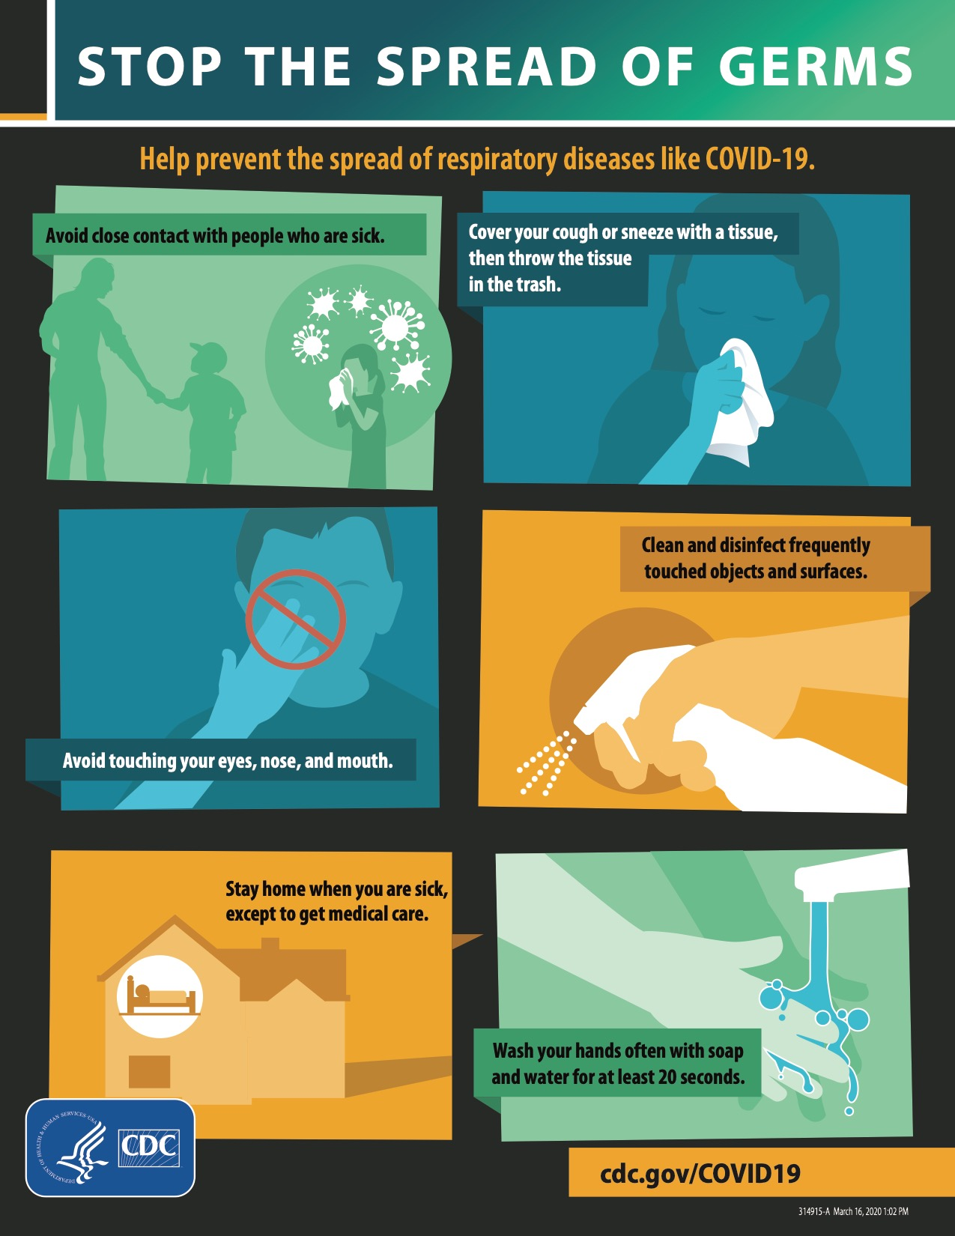

Appendix F: Code of Safe Practices

